Belleville Congregational Church

An Open and Affirming Congregation

of the United Church of Christ

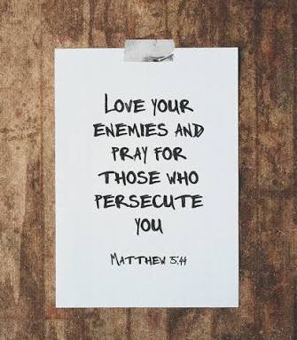

Mission of Belleville Church
Centered in the inclusive love of Jesus Christ, we seek to be a welcoming, affirming, and healing congregation. Led by the Holy Spirit, we are inspired to grow and be renewed through our worship, fellowship, scripture study, and the sharing of our gifts. Strengthened by God’s love and guidance, we strive to serve with compassion those in need, both near and far.
Let’s quiet our hearts and minds during the prelude to welcome God’s spirit.
October
25
2026
Led By: Rev. Ross Varney
Ushers: Peggy Utterback
Scripture Reader: Peggy Utterback
Coffee Hour: Peggy Utterback
Musician: Joyce Rice

- (*) where indicated, if able, please stand -

Prelude “Only upon You, Lord Jesus Christ” Johann Gottfried Walther

Greeting and Welcome Rev. Ross Varney

“Whoever you are, wherever you are on life’s journey, you are welcome here!”

Call to Worship

* Opening Hymn “A Mighty Fortress Is Our God” (PH #363)

* Lord’s Prayer…Our Father, who art in heaven, hallowed be thy name. Thy kingdom come, thy will be done on earth, as it is in heaven. Give us this day our daily bread. And forgive us our trespasses, as we forgive those who trespass against us. And lead us not into temptation, but deliver us from evil. For thine is the kingdom, and the power, and the glory forever. Amen.’

* Gloria Patri (PH #513)

Glory be to the Father, and to the Son, and to the Holy Ghost; As it was in the beginning, is now, and ever shall be, world without end. Amen. Amen

* Passing of Peace
As a sign of reconciliation with God, and with each other, please greet others, nearby, with a blessing such as “Peace be with you.”

Sharing Joys & Concerns
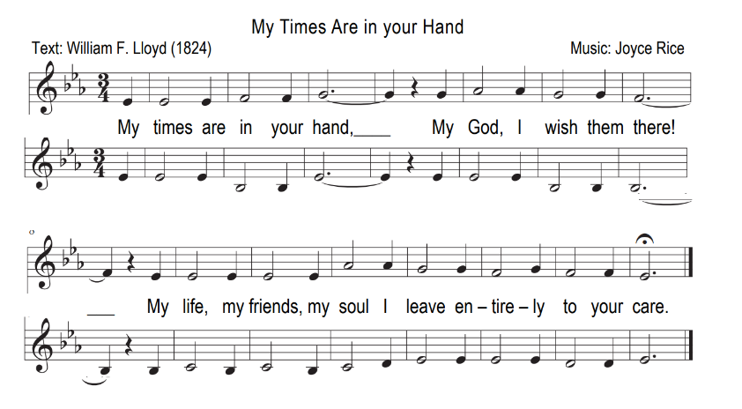
Call to Prayer

Prayer & Silent Prayer

Time for Children…of all ages

Scripture Readings Peggy Utterback

Proverbs 25:21
If your enemy is hungry, give him food to eat; if he is thirsty, give him water to drink.

Matthew 5:43-44
You have heard that it was said, ‘Love your neighbor and hate your enemy.’ But I tell you, love your enemies and pray for those who persecute you

Romans 12: 17-21
Do not repay anyone evil for evil. Be careful to do what is right in the eyes of everyone. If it is possible, as far as it depends on you, live at peace with everyone. Do not take revenge, my dear friends, but leave room for God’s wrath, for it is written: “It is mine to avenge; I will repay,” says the Lord. On the contrary: “If your enemy is hungry, feed him; if he is thirsty, give him something to drink. In doing this, you will heap burning coals on his head.” Do not be overcome by evil, but overcome evil with good.

Hymn “Jesus Christ, the Apple Tree” (see insert)
Sermon “Forgiveness is Difficult but Liberating” Rev. Ross Varney
Offering Time

Offertory My Hope Is Built Rick Barham
* Doxology, Dedication of Offerings Praise God from Whom all blessings flow;
Pilgrim Hymnal #515 Praise God, all creatures here below;
Praise God above, ye heavenly host;
Praise Father, Son and Holy Ghost. Amen
Announcements

*Closing Hymn “O Savior, Let me Walk with You” (NCH #503)

Benediction

Postlude Psalm 19 (The Heavens Declare) Benedetto Marcello


PRAYERS FOR JOYS AND CONCERNS
If you would like prayers for yourself or others, please place your request in the offering plate during worship service. You could also call/e-mail the office by Thursdays by 11:00 AM.

THIS WEEK

Bible Study - Thursdays at 1:00 PM

UPCOMING

Join us for Meditation Mondays - Take time to center and ground yourself weekly with 30 minutes of partially guided meditation beginning Monday Oct. 5th at 5pm in the Chapel with Lynn Varney. No sign-ups, drop in as you are able.

Lunch and Learn for Leaders (Pastors and Church Leaders)
online monthly each 1st and 3rd Sunday 12-1PM.
https://www.sneucc.org/lunch-learn-for-leaders-series

Christmas Fair and Christmas Café on November 7th at 9am – 12pm. All proceeds from the Christmas Café will go to school funds for Salonik!

A memorial service for Emery Rice will be held Tuesday, November 3rd in the Chapel with prelude music beginning at 10:50 am.

SERVICE SCHEDULE

If you are unable to perform the assigned task, please trade with someone on the list.

OCTOBER
Date | Usher | Scripture Reader | Coffee Hour
Oct 4th | Audrey Clarkson | Ben Heersink | Sue Heersink
Oct 11th | Liz Neale | Keith Barbera | Mardee Beauparlant
Oct 18th | Mary Lou Tyler | Jim Samuelson | SOUPS ON! See Gail
Oct 25th | Peggy Utterback | Peggy Utterback | Peggy Utterback

NOVEMBER
Date | Usher | Scripture Reader | Coffee Hour
Nov 1st | Audrey Clarkson | Babhekile Ssemwogerere | Sue Wolfendale &  Sue Heersink
Nov 8th | Sue Heersink | Barbara Colten | Lynn Varney
Nov 15th | Mardee Beauparlant | Rachel Shunamon | Rachel Shunamon
Nov 22nd | Babhekile Ssemwogerere | Ben Heersink | Bill Lincoln Coffee Hour
Nov 29th | Gail Gandolfi | Sandra Biondo | Gail Gandolfi
HAPPY BIRTHDAY

OCTOBER
7th - Lance Eskelund
8th - Virginia Lowell
13th - Denis Ipbuken
22nd - Keith Conway
24th - Janet Woodman
26th - Emily Fay
MUSIC SCHEDULE

OCTOBER
4th – Joyce Rice
11th – Joyce Rice
18th – Phil Cosgrove
25th – Joyce Rice

NOVEMBER
1st – Joyce Rice
8th – Phil Cosgrove
15th – Joyce Rice
22nd – Joyce Rice
29th – Phil Cogrove

NOVEMBER
4th - Mike Conaway
6th - Jamie Beauparlant
8th - Annika Ellis
10th - Jon Williamson
26th - Sue Wolfendale
28th - Christina Grandoni
29 Colin Dean

If you would like to add your birthday, please e-mail office@belleville-church.com

